Competition information no. 2

Nordic Championships in swimming for people with disabilities, intellectual disabilities and the Stockholm International Paragames in swimming and Masters.

WARM UP 1 hour before competition start.
Training session is available in the 50m pool on Friday 1/11 between 3:00 p.m. to 18:00. NOTE the change of time!

SWIM DOWN Lanes will be available in the 25m pool for swim down

MEDALS Medals is awarded to the top 3 in each event in classes S1-S13
Medals is awarded to the top 3 in each event in S14
Medals is awarded to the top 3 Master swimmers in each event.
Medal awarded to the top 3 in each event/class K1-K4
The best male and female performance will be awarded with a trophy. The trophies will be donated by Frösunda Care AB/Team Frösunda.

CHANGE IN HEAT 150m individual medley and 200m medley will swim in separate heats

ENTRY LIST Will be presented at www.livetiming.se, Open Nordic Campionship and the Stockholm International Paragames, Eriksdalsbadet, Stockholm
Changes emailed to stockholmparagames@gmail.com

COACH MEETING Will be held Saturday at 7:50 in the large conference room at Eriksdalsbadet. Follow the signs

TRANSPORT Request for help with transportation from the airport to the venue must be received no later than October 11

INVOICE Will be sent out after race. If a different billing adress than the e-mail adress, please e-mail it to stockholmparagames@gmail.com

LUNCH Can be pre-ordered at a cost of 90 SEK/portion. Lunch may be pre-ordered no later than October 11 at a cost of 90 SEK/portion. Note! Communicate allergies.

PARKING Please park at the back of the venue next to the badminton hall. The parking is monitored by two different operators, please pay at the correct machine. .
With disability permit you can park by the road down to the boat club.

MAP Map with Eriksdal marked and a walkway from Clarion Hotel at the entrance to the competition pool. The walkway is signposted.

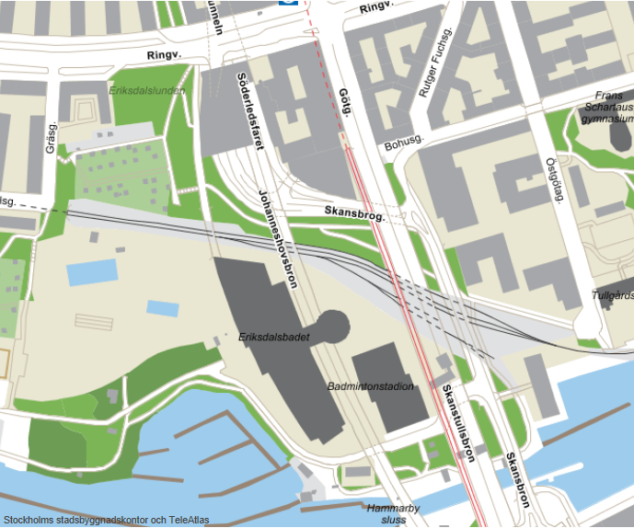
Entré till tävlingsbassängen
Clarion Hotel

